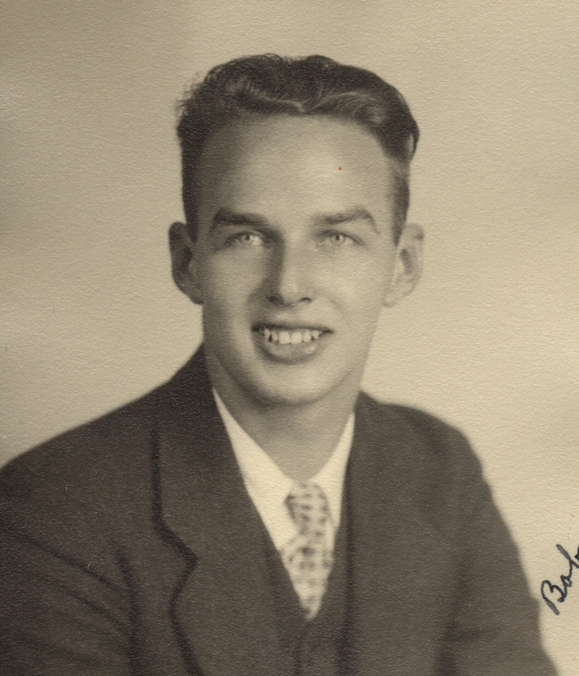
Robert Steeg Moon was the only child born to William Moon (1888) and Gertrude Steeg (1890). Bob was born in Sacramento, Sacramento County, CA on the 6th day of July 1916. By 1920 he was a resident of Oakland, Alameda County, CA. His family lived at that time at 481 Pedestrian Way on the border of North Oakland and Berkeley. Most of the pictures of his childhood and teen years were taking from this area. The picture just below was taken about 1918 with Bob sitting on his bike with his father William.
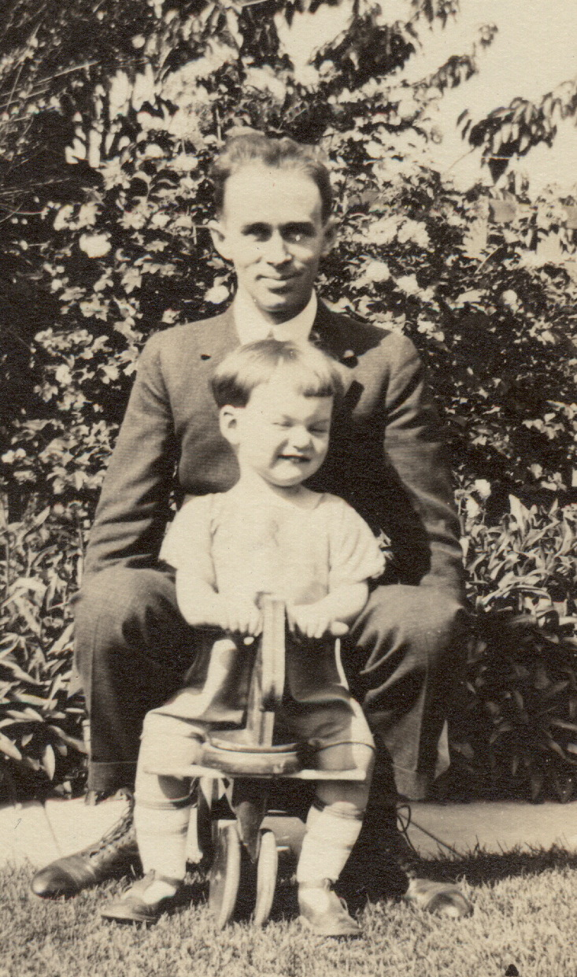
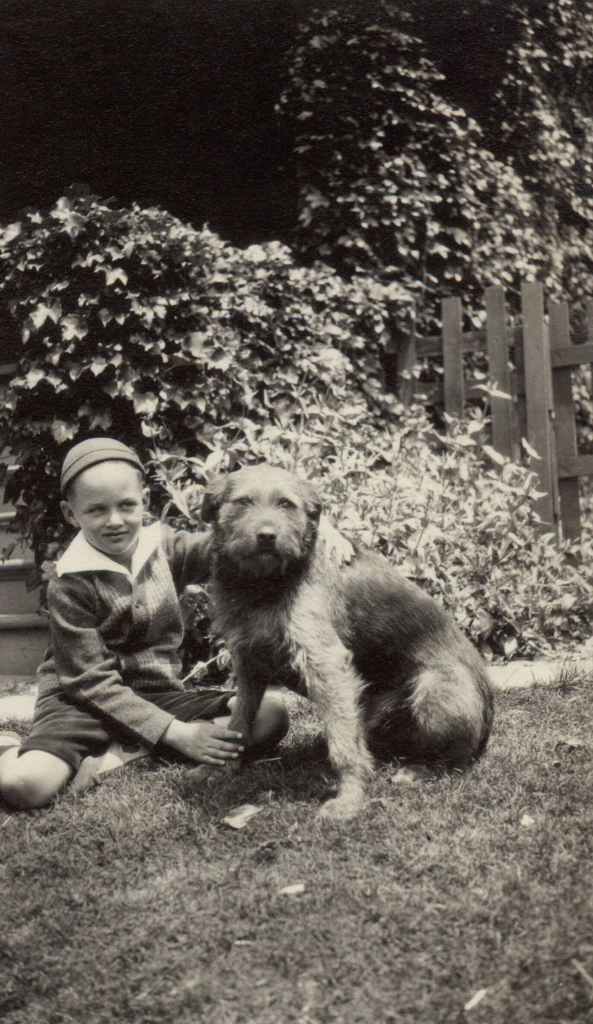
There is very little known about the elementary years and only some known about the high school years. Bob had a dog indicated by the picture below. Bob attended University High, which to day does not exist. During his youth he played many sports but was most involved with basketball and tennis. He told two stories that I remember. The first is about a shot he made while playing “B” basketball in high school. The game was about over just a second or two left and all were about to run off the court so he through the ball behind his back and swished the basket. Also he told of playing tennis with Don Budge. He said that there wasn’t much playing going on because even then Don was one of the greatest players in the world.

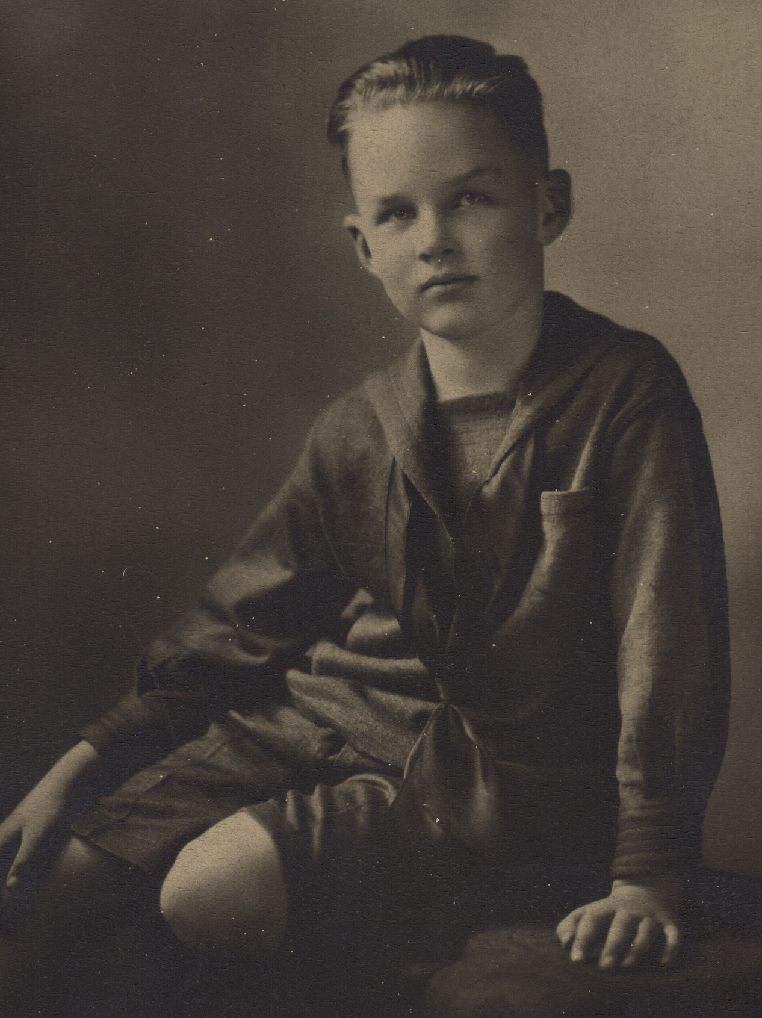
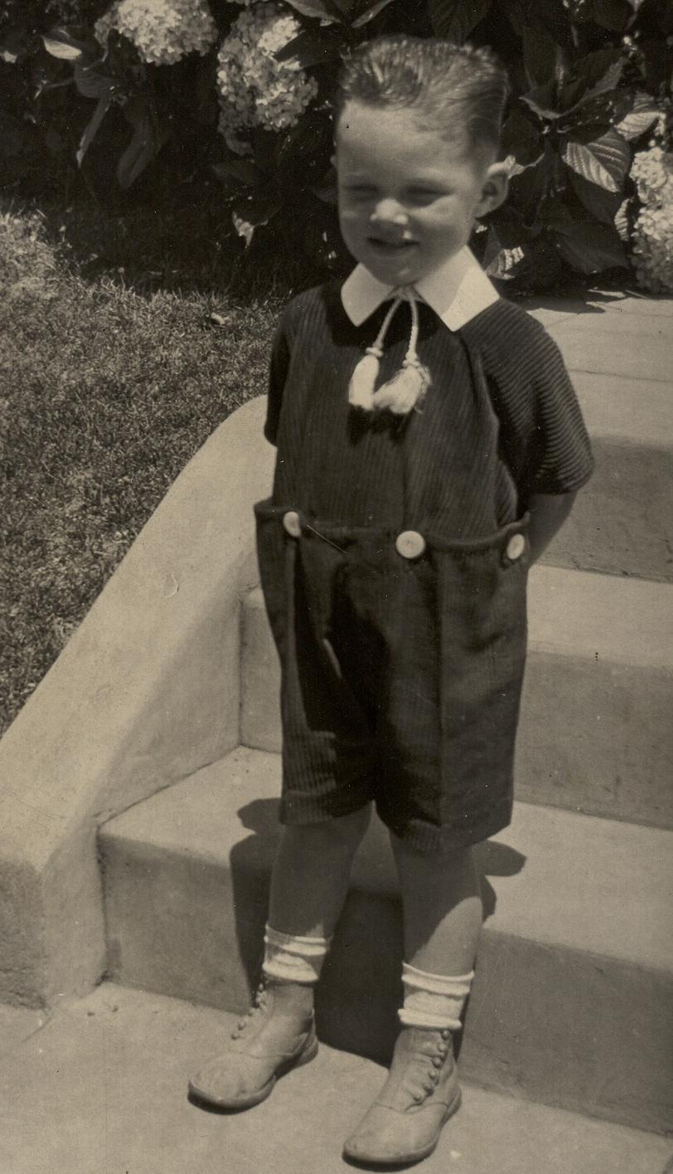

Circa 1920 1924

Picture above left is of Bob about age four in front of the Moon home on Pedestrian Way in Oakland. The picture above right was taken in 1924. Picture below left is of Bob and his mother Gertrude Steeg Moon abt. 1936 The Picture below right is of Bob and his aunt Grace Moon Leonard also taken circa 1936.

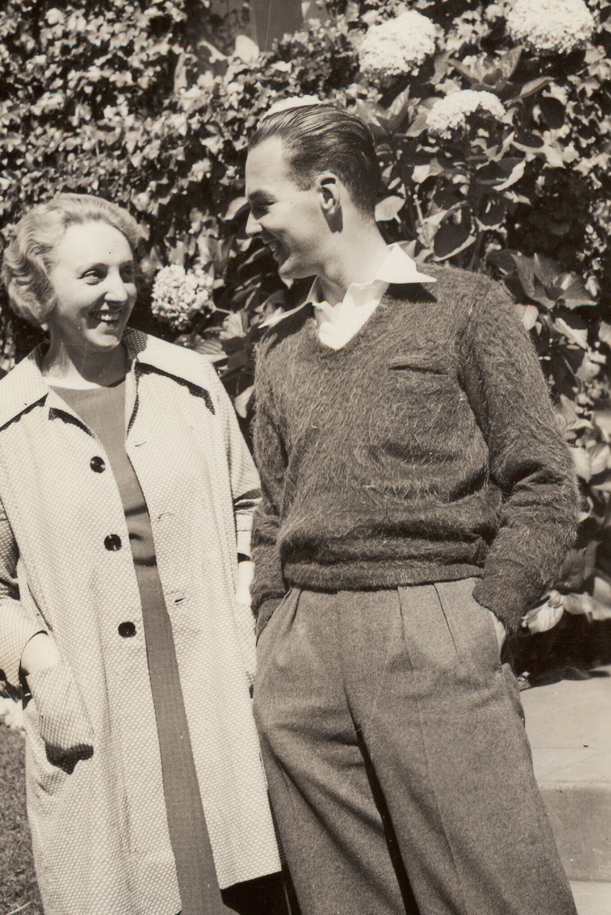
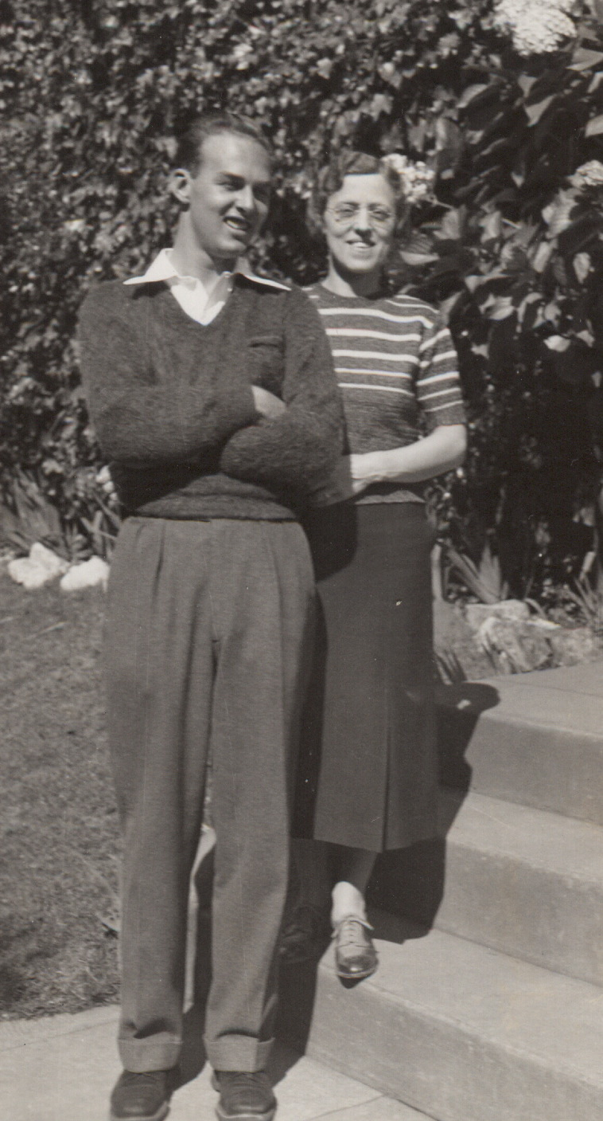

In June of 1934 Bob graduated from University High School in Berkeley. He then went on to attend University of California, Berkeley, studying Architecture. At the end of his fourth year at Berkeley and WWII being in full swing, Bob was inducted into the Army on February 1, 1941 in San Francisco. At that time his record shows he was an auto parts salesman and played the Oboe in a band. He started out as an infantryman and then immediately enrolled in OCS and went to Ft. Benning, GA to become a commissioned officer. The attached military record indicates the following;
He was an infantry Unit Commander with specialty in Supply and Evacuation. He served in Ardennes, Central Europe, Rhineland and the Aleutian Islands. For his service he earned the Bronze Star Central Europe, combat Infantry badge, Asiatic Pacific Ribbon and the ETO Ribbon.
Bob served in Alaska between June 1942 and August of 1943. He went to Europe in Oct 1944 and returned July 1945.
I vaguely remember stories he told about some of the experiences he had during the war. In his job of procurement he was often ordered to find special food and drink for the higher ranked officers. He also told stories of how hard it was to come back to Georgia from Alaska. He said his blood had thickened up so much that it was hard to get enough oxygen. He said that many of the men after coming back would pass out at parade.
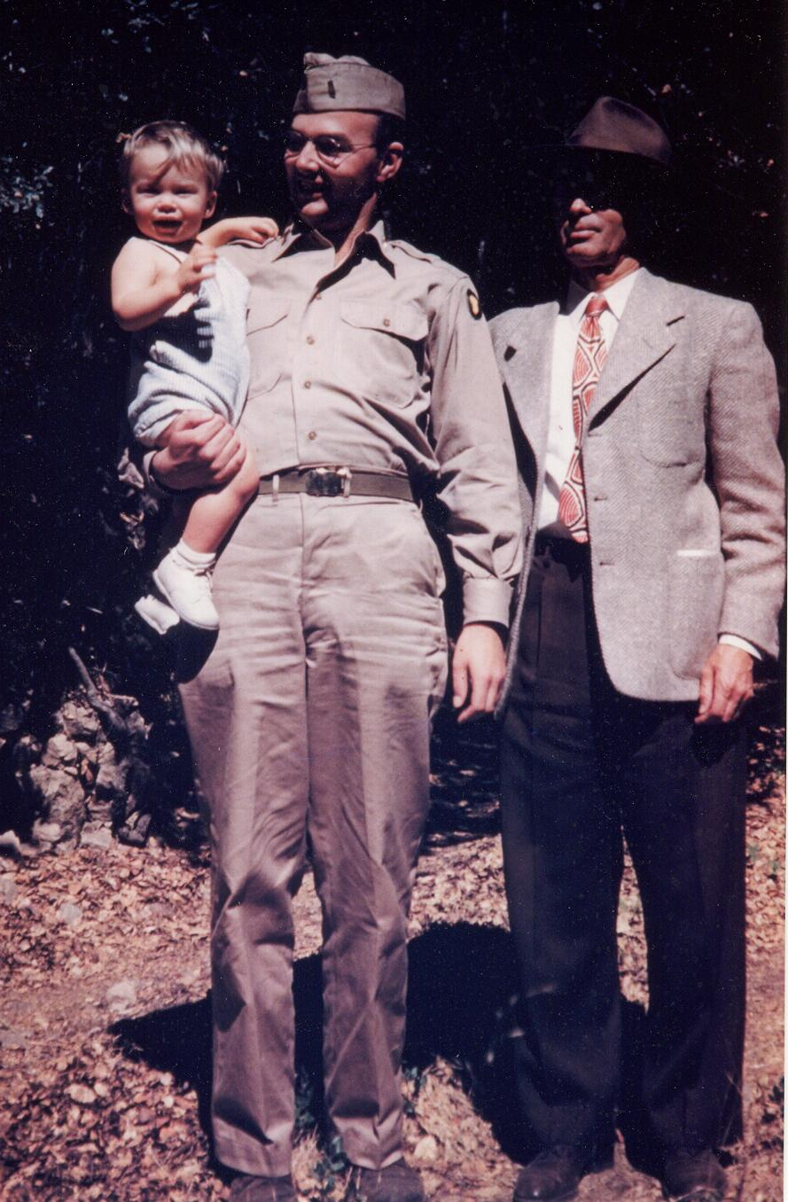
Picture to the left was taken circa 1945-1946 in Zyanti, CA near Felton. The families were spending a weekend at the Hewitt’s summer cottage. Bob Moon Jr. on the left, father Bob Moon Sr. middle and grandfather Wm Moon right.

At the end of the war Bob was assigned to the reserve officer corps. out of the Presidio in San Francisco. He received his final papers of separation prior to the Korean conflict in 1952.
Shortly after this picture was taken Bob Sr. came down with the Polio virus. I remember mom placing hot towels on his legs everyday to soften the muscle tissue and keep the muscles from tightening up. He must have been in a lot of pain in those days because I remember the anguish on his face when she put those hot towels on him.
He was a real fighter. Many people succumbed to the disease or were severely handicapped by it. He seemed to know he would be able to beat it. He did. His legs were slightly weaker than before the disease but he was able to strengthen other muscles that would allow him to walk without even the slightest limp.

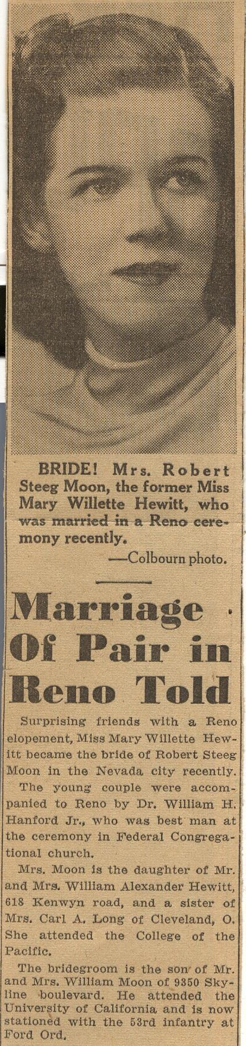
Bob and Billie Hewitt had known each other since about 1936. Had dated and had become a couple. They had put off marriage until they could afford it. But as many couples did in the War days they decided to get married and spend what time they may have left together. So Bob married Mary Willette Hewitt in Reno, NV on the 4th of September 1941 about 8 months after his induction into the army. As many did they found time during a furlough to elope skipping the long drawn out church wedding ceremony that the Hewitt’s would insist on having. The case of Bob and Mary was probably pretty typical in those days. Bob had been stationed temporarily at Fort Ord, Monterey, CA. One month later he sent the following letter and newspaper article to his grandfather George and family in Detroit. It is a touching piece of family history.
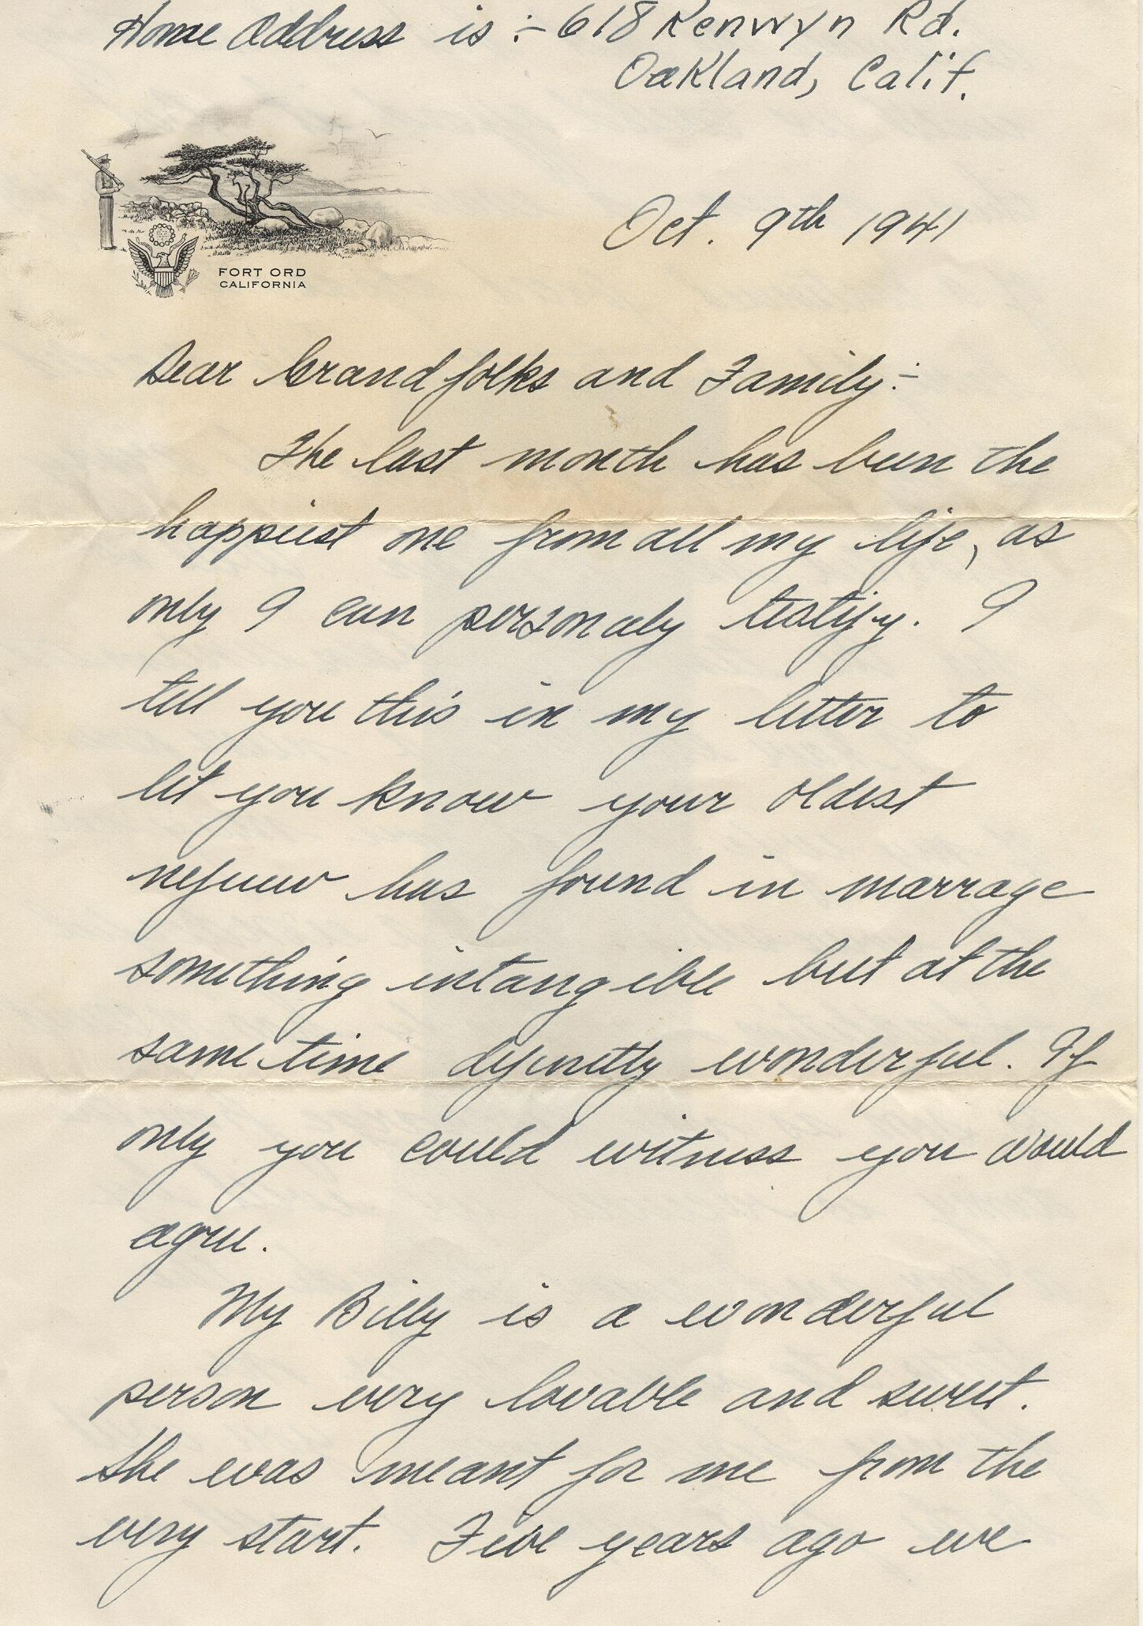

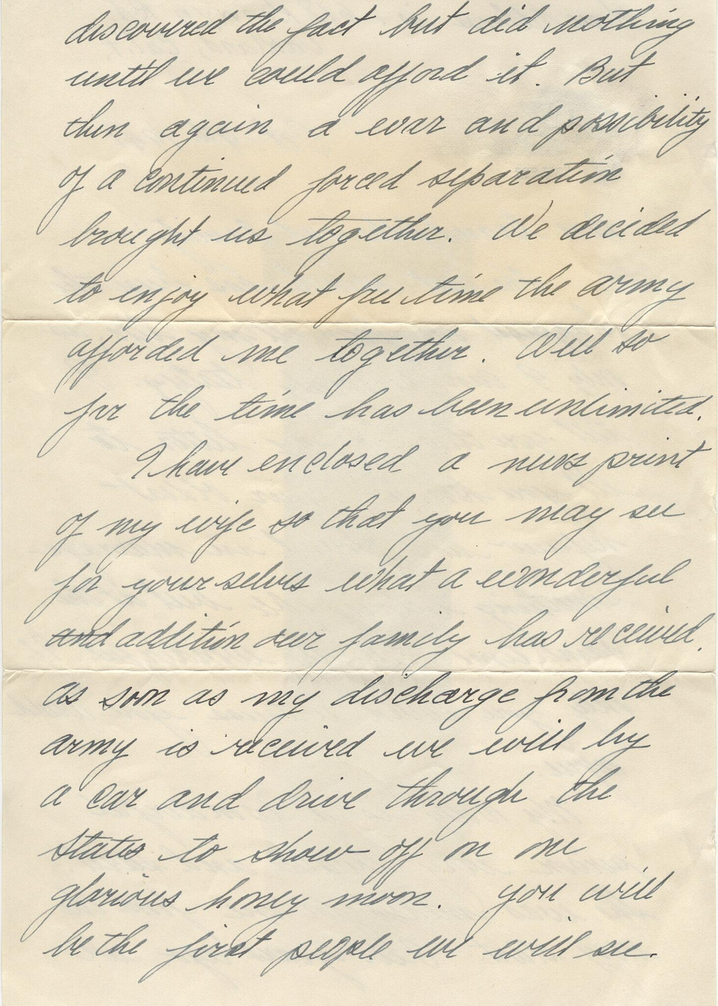
Dear Grand folks and Family,
The last month has been the happiest one from all my life, as only I can personally testify. I tell you this in my letter to let you know your oldest nephew has found in marriage something intangible but at the same time distinctly wonderful. If only you could witness you would agree.
My Billie is a wonderful person very loveable and sweet. She was meant for me from the very start. Five years ago we discovered the fact but did nothing until we could afford it. But then again the possibility of a continued forced separation brought us together. We decided to enjoy what free time the army afforded me, together. Well so far the time has been unlimited.
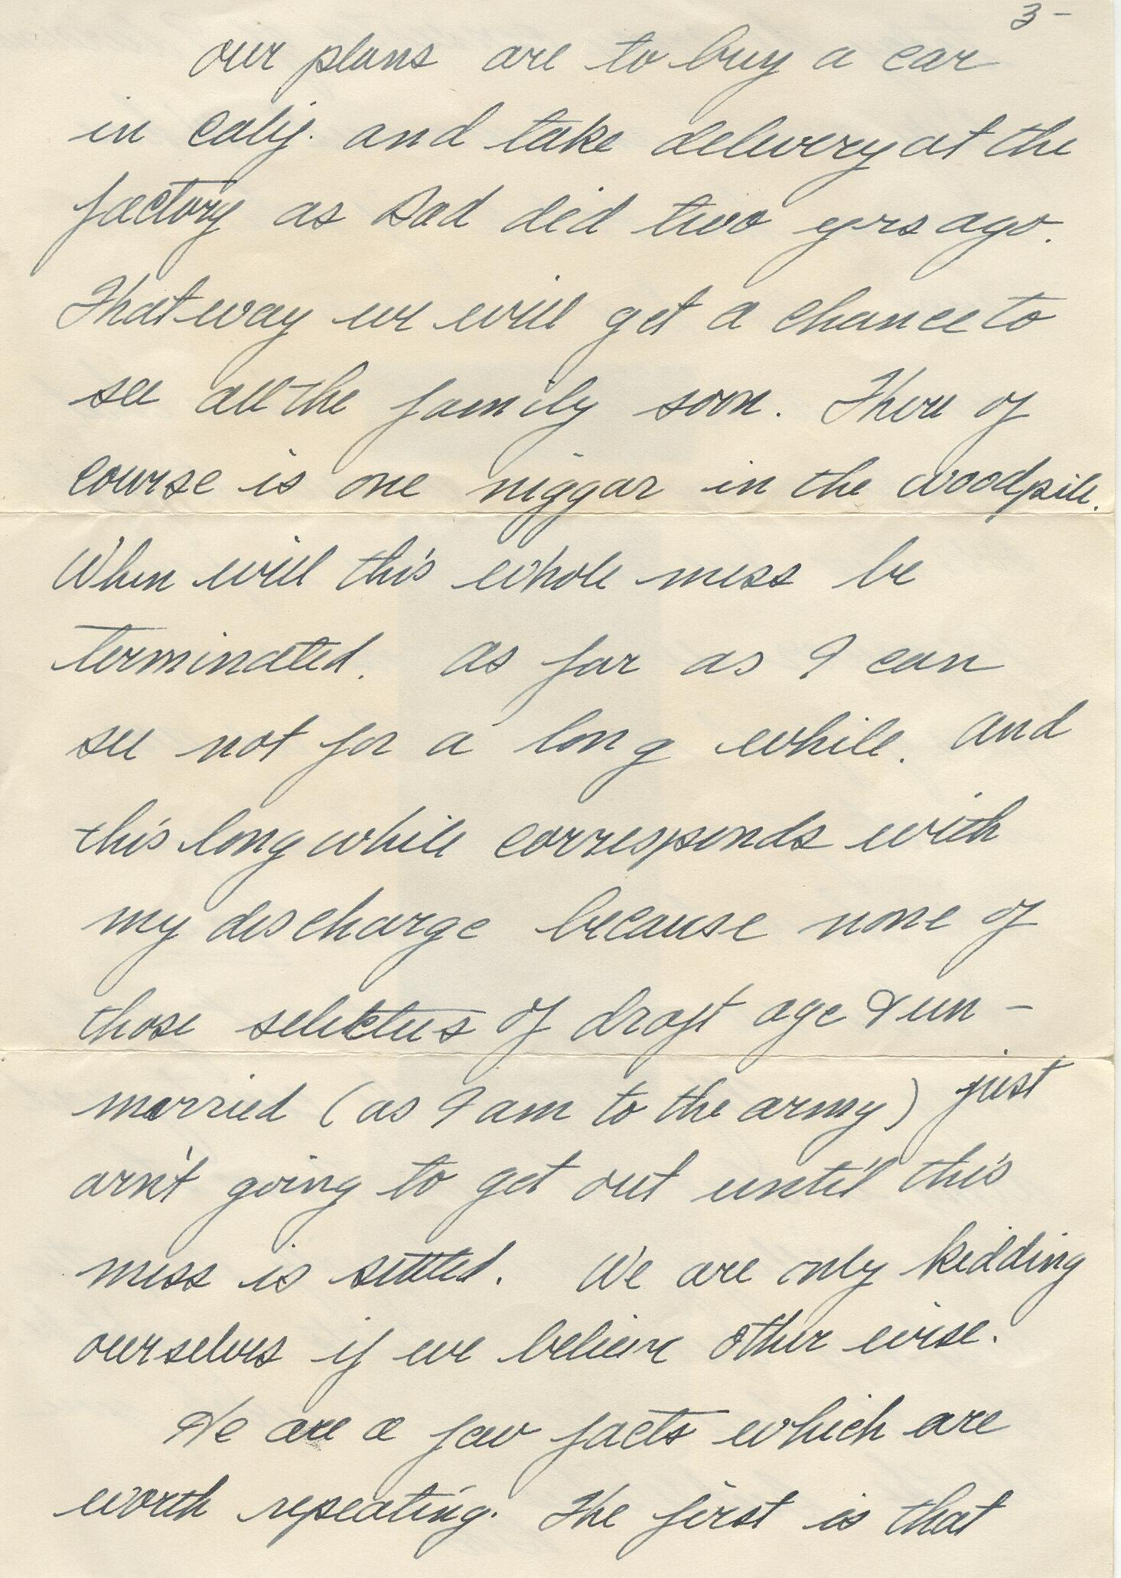
I have enclosed newsprint of my wife so that you may see for yourselves what a wonderful addition our family has received. As soon as my discharge from the army is received we will by a car and drive through the states to show off on one glorious honeymoon. You will be the first people we will see.
Our plans are to buy a car in California and take delivery at the factory as Dad did two years ago. That way we will get a chance to see all the family soon.

There is of course on niggar in the woodpile. When will this whole mess be terminated? As far as I can see not for a long while. And this long while corresponds with my discharge because none of those selectee’s of draft age and unmarried (as I am to the army) just aren’t going to get out until this mess is settled. We are only kidding ourselves if we believe otherwise. Here are a few facts that are worth repeating. The first is that today the army consists of 9 divisions fully armed and manned.

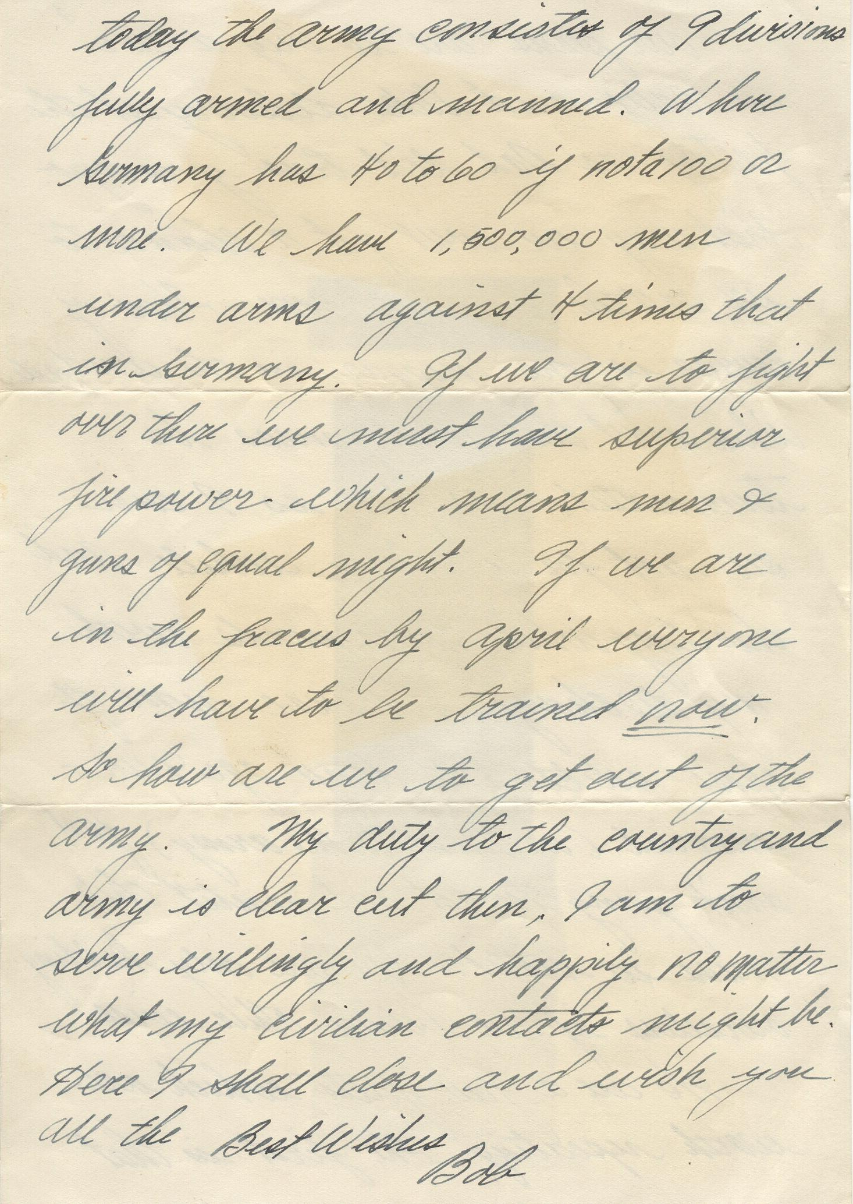
Where Germany has 40 to 60 if not a 100 or more. We have 1,500,000 men under arms against 4 times that in Germany. If we are to fight over there we must have superior firepower, which means men, and guns of equal might. If we are in the fracas by April everyone will have to be trained NOW. So How are we to get out of the army. My duty to the country and army is clear-cut then, I am to serve willingly and happily no matter what my civilian contact might be. Here I shall close and wish you all the Best Wishes
Bob

Bob and Billie lived at Fort Ord and in Georgia and South Carolina as they were transferred to different venues. When Bob was in Alaska and in Europe Billie lived at home in Oakland. Their first child was still born. But in June of 1944 while in South Carolina their second child was born. They named him Robert Steeg Moon Jr. as many families did, after the father.

Bob worked for a furniture store in Oakland washing windows, delivering furniture and setting up displays. It wasn’t long before he was selling furniture and designing interiors for Bonyng’s of Oakland one of the more prestigious furniture stores in California.
Billie and Bob had two more children, Sally Ann born on 12 July 1946 and Mary Alice born 28 September 1949. they had originally bought a house in Oakland near the Airport. In 1946 they moved to Walnut Creek near what is now Olympic Blvd and California St. In 1955 they bought another home located just off Ygnacio Valley Rd.The family lived there from 1955 until 1972.
Bob and Billie like several activities that seemed to be a passion for them. Bob Loved taking pictures of Billie, the family and of trips to special places he would take us to.

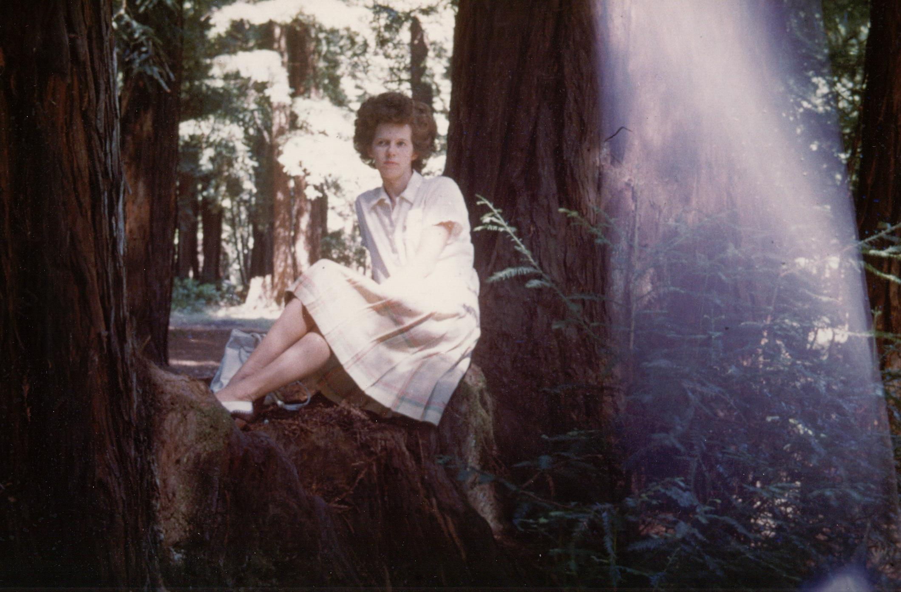
Besides travels to missions and the High Sierra Bob and Billie loved to play bridge with their friends as well as talk about issues of the day. Bob had a propensity for taking the opposite side of an issue just to have a discussion or argument. However, in his later years he was known to start on one side of an issue and gravitate to the other side before the discussion was over.
Bob was active in the surrounding community. He was a commissioner with the local boy scout organization and was instrumental in designing and getting the community to build the Rancho San Miguel Swim Club.

In 1962 Bob’s father died. Up to that point Bob had worked at Bonyng’s going on17 years. With the passing of his father and because his Aunt had left him a tidy sum of money he was able to start his own business he named Robert Moon Interiors. At first he worked out the house but finding a need for more space and as business increased he decided to open a decorating shop by the same name at the corner of Oak Grove and Ygnacio Valley Rd. in Walnut Creek. His business was very successful. It was mostly successful not only because of his talent but because he was able to give customers the attention and professional guidance they expected and enjoyed. He was very good at what he did and he was able to build a good reputation.

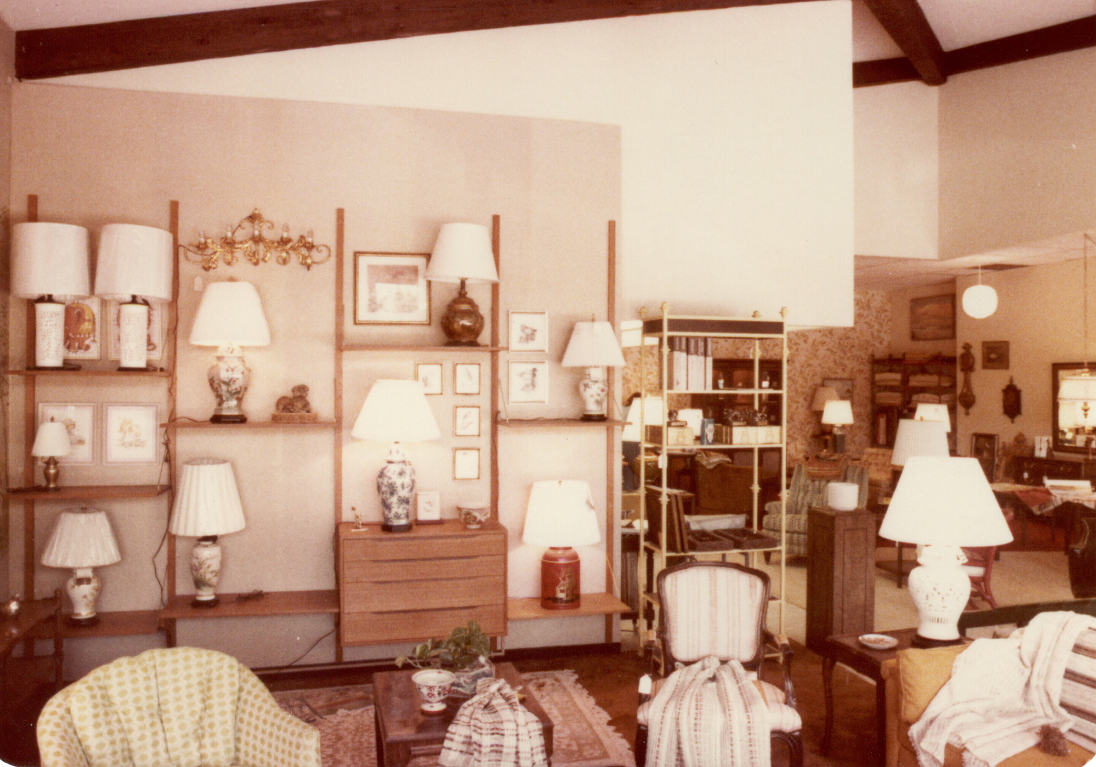
Life changed drastically and forever when in 1970 Billie was diagnosed with an advanced case of breast cancer. She under went chemotherapy and when that did not work radical mastectomy was preformed in an attempt to save her life. All doctors tried to do eventually was not enough. Billie passed away in December of 1972.

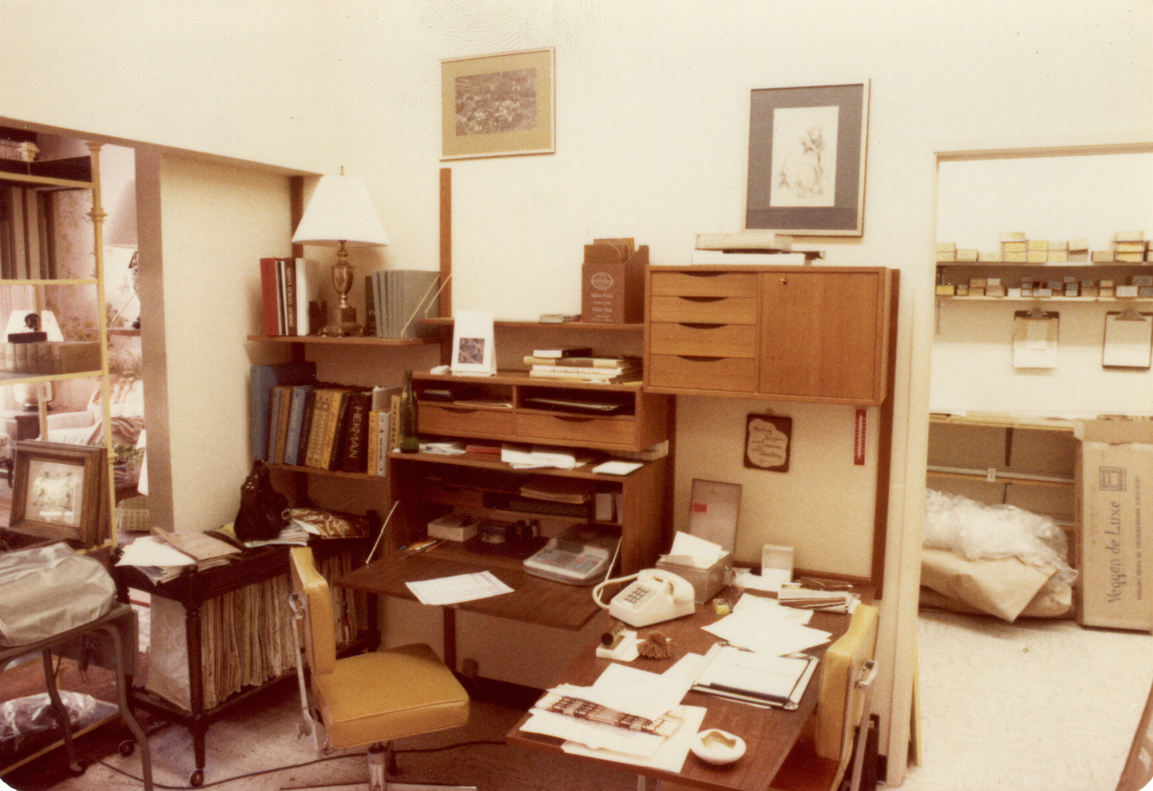
She had been instrumental in helping set up and work the shop. For almost 10 years they worked together fulfilling a life long dream. Life had been good and they had managed to succeed even through war, polio and teenagers.
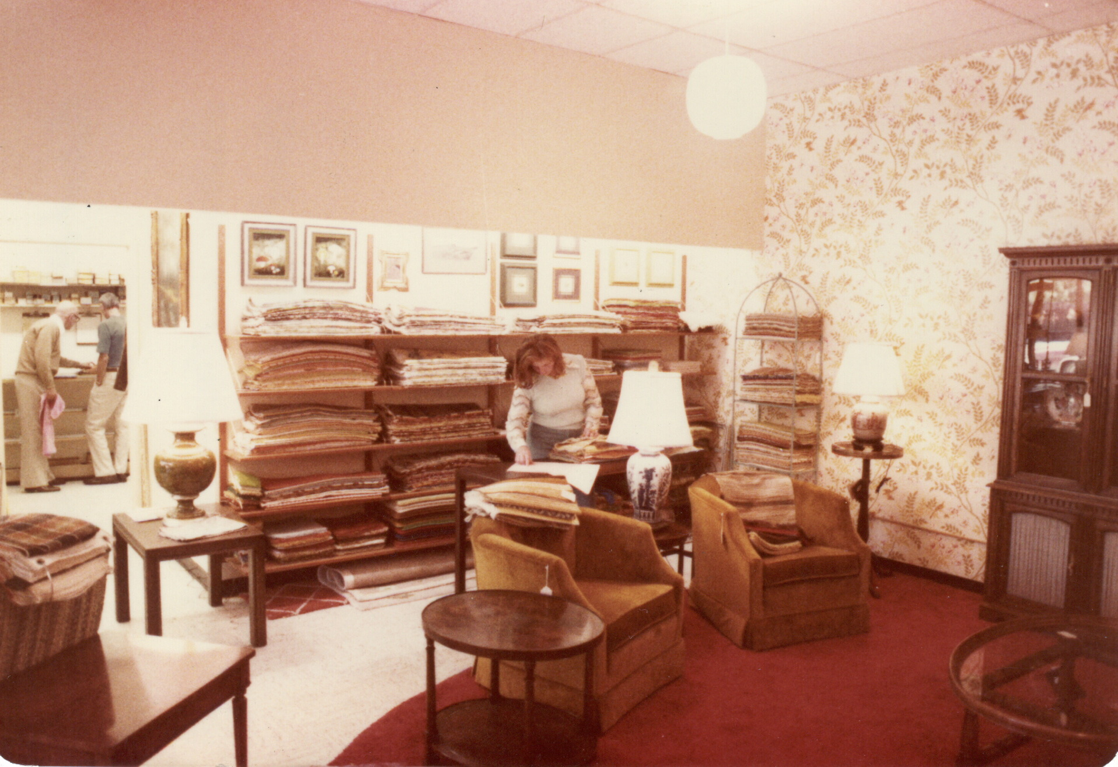
After Billie’s death Bob just wanted to be away from the memories so he bought a condominium at the corner of Bancroft and Treat Blvd. in Walnut Creek. Not wanting to completely be rid of the life he and Billie had spent together Bob Jr. and Patricia (daughter in law shown below) lived in the house at 254 Los Cerros ave. Walnut Creek for the next year.
Patty took on many of the responsibilities that Billie provided. After that year the house was sold.

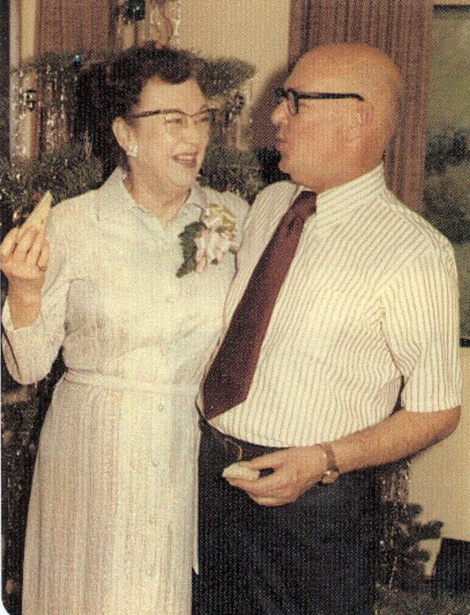
After about a year had passed friends of Bob and Billie from Ivy Ct. Morrie and Vi Thompson decided Bob had been single long enough and introduced him to another widow friend Helen Shields. On November 21, 1973 Bob married Helen Elizabeth Donnelly Shields Moon again in a non church wedding. They toured the northwest and Olympic coast and then took a trip to the Hawiian Islands. They also built a house above Marysville/Yuba city in a quiet community called Mary Mountian off of highway 20. They lived there and at the Condo for four years before she died of a heart attack on 22 Jan 1977.

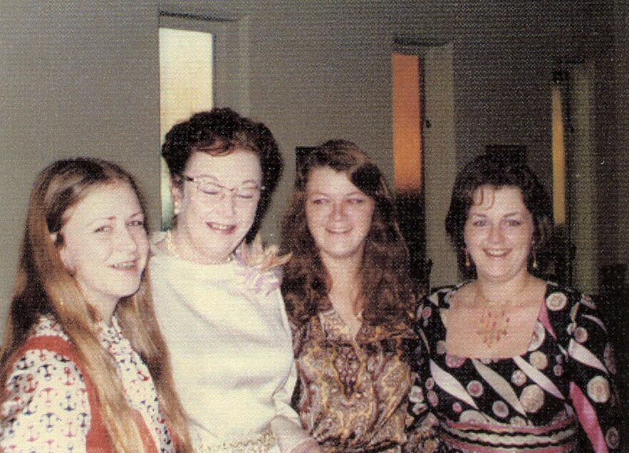
Below is Helen with three of her four daughters. From left to right Patricia (Pooh), Helen, Tia and Dorthy (Dotty). A fourth daughter Sandy lived in Hawaii at the time.

After Helen’s death Bob married their Mary Mountain next door neighbor Fanita Stindell.
The marriage took place in Carson City Nevada sometime in 1978. No one in the family was invited. The date has not been verified and pictures have not been found as of this date.

